**Thursday May 14, 14.30-16.30**

**On line webinar on zoon.us**

**https://sas.zoom.us/j/3547110070**

**dr. Cinzia GIANFIORI**

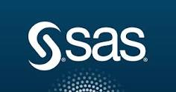

**SAS Academic Program Manager**

Dr. Costabile Santis and Dr. Daniele Goretti - SAS Education

**SAS Analytics**

Abstract: SAS is a software suite developed by SAS Institute that offers advanced analytics, multivariate analyses, business intelligence, data management, predictive modelling, text mining, machine learning visual analytics and more. SAS suite is one of the most used analytics platform among researchers working with very large data.

In this talk, the SAS platform will be presented, with a particular focus on Business Intelligence, Big Data Analytics, Visual Statistic and Machine learning.

In addition, the SAS initiative for undergraduate and graduate students will be described, as well as the Certification Program of SAS

Info: **Prof. Antonio PICARIELLO -** tel. 081 7683826 – antonio.picariello@unina.it