Tuesday 14 January 2020, Time:10.30-11.30
Meeting room 4.19, 4th floor, Floor I, Ed. 3/A DIETI - Via Claudio, 21 NAPOLI

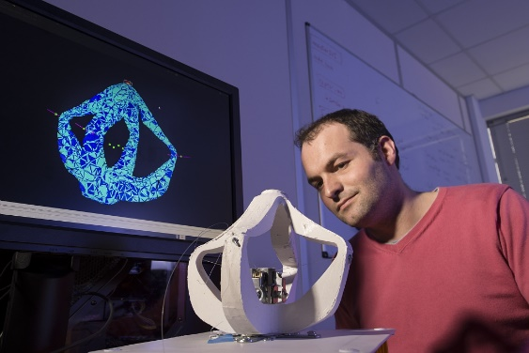
Dr. Christian DURIEZ
INRIA – Lille – Nord-Europe Lille1 University, France. Research Director, Head of DEFROST team
Research Topics: Real-time simulation, Deformable models, Contact response, Haptic Rendering and Robotics
https://team.inria.fr/defrost/team-members/christian-duriez/

Numerical methods for modeling, simulation and control for soft robots or robots in interaction with deformable environment

Abstract: The basis of mechanics in robotics are often based on rigid bodies assumption. Yet, many applications involve deformable environments and there is a growing interest of developing robots that deforms: soft robotics opens very interesting perspectives in terms of human interaction, new applications, cost reduction, robustness, security. However, traditional modeling and control methods used in robotics do not fully apply when deformation is involved. During this talk, this scientific challenge of modeling and control of soft robot will be presented. I will also present some of our contributions which make use of methods from numerical mechanics (like Finite Element Methods) and adapt them to fulfill the constraints of robotics: real-time computation, direct and inverse kinematic models, closed loop control.

CV (from the Lecturer): I received the engineering degree from the Institut Catholique d’Arts et Métiers of Lille, France and a PhD degree in robotics from University of Evry, France. My thesis work was realized at CEA/Robotics and Interactive Systems Technologies followed by a postdoctoral position at the CIMIT SimGroup in Boston. I arrived at INRIA in 2006 in the ALCOVE team to work on interactive simulation of deformable objects and haptic rendering. In 2009, I was the vice-head of SHACRA team and focus on medical simulation. I am now the head of DEFROST team, created in January 2015. My research topics are Soft Robot models and control, Fast Finite Element Methods, simulation of contact response and other complex mechanical interactions, new algorithms for haptics… All my research results are developed in SOFA, which is a framework that we co-develop with other INRIA teams. I was also one of the founders of the start-up company InSimo which use our research results for a fantastic humanitarian project (see the proof of concept)!
Info: Prof. FANNY FICUCIELLO - tel. 081 7683916 – fanny.ficuciello@unina.it

