Giovedì 11 Giugno 2020, Ore: 16.00-17.30
Sulla piattaforma Microsoft TEAMS,
TEAM: "Seminari di Elettromagnetismo per Ing. Biomedica LM"
Codice di accesso: wyesrid

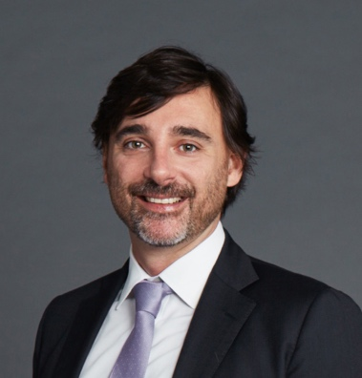
Prof. RICCARDO LATTANZI
New York University, USA
Grossman School of Medicine, Department of Radiology
https://med.nyu.edu/faculty/riccardo-lattanzi

Noninvasive Mapping of Electrical Properties using MRI

Knowledge of the spatial distribution of electrical conductivity and permittivity is valuable both as an adjunct for various diagnostic and therapeutic technologies (e.g. for TMS, RF ablation, or in vivo SAR mapping in high-field MRI), and perhaps even more as a new window on the microstructure and function of tissues and materials, complementary to that provided by traditional imaging modalities. Recently, magnetic resonance has begun to play a key enabling role in noninvasive electrical property mapping, for example by providing internal information to overcome the ill-conditioned inverse problem of surface-based electrical impedance tomography. Here, we describe two techniques for electrical property mapping: Local Maxwell Tomography (LMT) and Global Maxwell Tomography (GMT). LMT reconstructs conductivity and permittivity on a voxel–by–voxel basis by inverting the Helmholtz equation, using complementary information from the transmit and receive sensitivity distributions of multiple coils to resolve ambiguities. GMT estimates electric conductivity and permittivity by solving an inverse scattering problem based on magnetic resonance measurements. GMT relies on a fast volume integral equation solver for the forward path and infer all electrical properties in a volume at once

Riccardo Lattanzi is an associate professor of radiology, electrical and computer engineering at the New York University. His research work lies at the boundary between physics, engineering and medicine. He investigates fundamental principles involving the interactions of electromagnetic fields with biological tissue in order to improve the diagnostic power of magnetic resonance imaging. His honors include an ISMRM Young Investigator Award and an NSF CAREER Award. He holds a degree in electronic engineering from University of Bologna and a Ph.D. in medical engineering and medical physics from the Harvard-MIT Division of Health Sciences and Technology.
Info: Prof. Rita Massa - tel. 081 676844 – rita.massa@unina.it
Prof. Giuseppe Ruello - tel. 081 7683512 – ruello@unina.it

